**ADVANCE EXCEL ASSIGNMENT - 06**

**1. What are the various elements of the Excel interface? Describe how**

**they're used.**

**1. Quick Access Toolbar**

This toolbar is located in the upper left corner of the screen. Its objective is to show the most frequently used Excel commands. We can customize this toolbar based on our preferred commands.

**2. File Tab**

Excel 2007's Office button has been replaced by the File tab. We can click it to check the Backstage view, where we can open or save files, create new sheets, print sheets, and perform other file-related operations.

**3. Title Bar**

The title bar of the spreadsheet is at the top of the window. It displays the active document's name.

**4. Control Buttons**

Control buttons are the symbols that are present in the upper-right side of the window, enabling us to change the labels, minimize, maximize, share, and close the sheet.

**5. Menu Bar**

Under the diskette or save icon or the excel icon (this will depend on the version of the program), labels or bars which enable changing the sheet which is shown. These are the menu bar and contain a File, Insert, Page Layout, Formulas, Data, Review, View, Help, and a Search Bar with a light bulb icon. These menus are divided into subcategories which simplify the distribution of information and analysis of calculations.

**6. Ribbon/Toolbar**

Each menu bar contains several different elements. On the selection of the menu, a sequence of command options/icons will show on a ribbon. For example, if we select the "Home" tab, we will see cut, copy, paste, bold, italic, underline, and more commands. In the same way; we can click on the "Insert" tab, we will see tables, illustrations, additional, recommended graphics, graphics maps, among others. On the other hand, if we select the "Formulas" option. Insert functions, auto sum recently used, finances, logic, text, time, date, etc.

Ribbon/Toolbar is a set of commands organized into three sections.

* **Tabs**

They are the Ribbon's top part, and they include groups of related commands. Ribbon tabs include Home, Insert, Page Layout, Formula, Data.

* **Groups**

They organize related commands; the name of each group is displayed below the Ribbon. For example, a set of commands related to fonts or a group of commands related to alignment, etc.

* **Commands**

They appear within each group, as previously stated.

**7. Dialog Box Launcher**

Dialog box launcher is a very little down arrow that is present in the lower-right corner of a command group on the Ribbon. By clicking on this arrow, we can explore more options related to the concerned group.

**8. Name box**

Show the location of the active cell, row, or column. We have the option of selecting multiple options.

**9. Formula Bar**

Formula bar permits us to observe, insert or edit the information/formula entered in the active cell.

**10. Scrollbars**

Scrollbars are the tools that enable us to move the document's vertical and horizontal views. We can activate this by clicking on the platform's internal bar or the arrows we have on the sides. Additionally, we can use the mouse wheel in order to automatically scroll up or down: or use the directional keys.

**11. Spreadsheet Area**

It is the place where we enter our data. It includes all the rows, cells, columns, and built-in data in the spreadsheet. We can use shortcuts to perform toolbar activities or formulas of arithmetic operations (add, subtract, multiply, etc.). The insertion point is the blinking vertical bar known as the "cursor." It specifies the insertion location of the typing.

**12. Leaf Bar**

Leaf bar is present at the bottom of the spreadsheet, which says sheet1 is shown. This sheet bar describes the spreadsheet which is currently being worked on. Using this, we can alternate a number of sheets or add a new one as per our convenience.

**13. Columns Bar**

Columns are a vertically ordered series of boxes across the full sheet. This column bar is located below the formula bar. The letters of the alphabet are used to label the columns. Begin with the letter A to Z, and then after Z, it will continue as AA, AB, and so on. The number of columns that can be used is limited to 16,384.

**14. Rows Bar**

The row bar is the left part of the sheet where a sequence of numbers is expressed. Begin with number one (1), and further rows will be added as we move the pointer down. There are a total of 1,048,576 rows available.

**15. Cells**

Cells are those parallelepipeds that divide the spreadsheet into many pieces, separating rows and columns. A spreadsheet's first cell is represented by the first letter of the alphabet and the number one (A1).

**16. Status Bar**

The status bar is present at the bottom of the window that displays critical information. It also indicates whether something is incorrect or whether the document is ready to be printed or delivered.

This shows the result of the selected digits such as sum, average, count, maximum, minimum, etc.

By right-clicking on the status bar, we can configure the status bar. Any command from the specified list can be added or removed.

**17. View Buttons**

View buttons are a set of three buttons arranged at the left of the Zoom control, close the screen's right-bottom corner. We can see three different kinds of sheet views in Excel using this method.

* **Normal View:** - Normal view displays the Excel page in normal view.
* **Page Layout View:** - The Page Layout view shows the precise layout of an Excel page it will be printed.
* **Page Break View: -** This displays page break preview before printing.

**18. Zoom Control**

The zoom control is present at the lower-right side of the window. It enables us to ZOOM-IN or ZOOM-OUT a specific area of the spreadsheet. It is represented by magnifying icons with the symbols of maximizing (+) or minimizing (-)

**2. Write down the various applications of Excel in the industry.**

* Data Entry and Storage
* Performing Calculations
* Data Analysis and Interpretation
* Reporting and Visualizations
* Accounting and Budgeting
* Collection and Verification of Business Data
* Calendars and Schedules
* Administrative and Managerial Duties
* Forecasting
* Automating Repetitive Tasks

**3. On the ribbon, make a new tab. Add some different groups, insert**

**commands in the groups and name them according to their commands**

**added. Copy and paste the screenshot of the steps you followed.**

**Step-1**

In the Customize the Ribbon window, under the list of tabs, click the New Tab button.

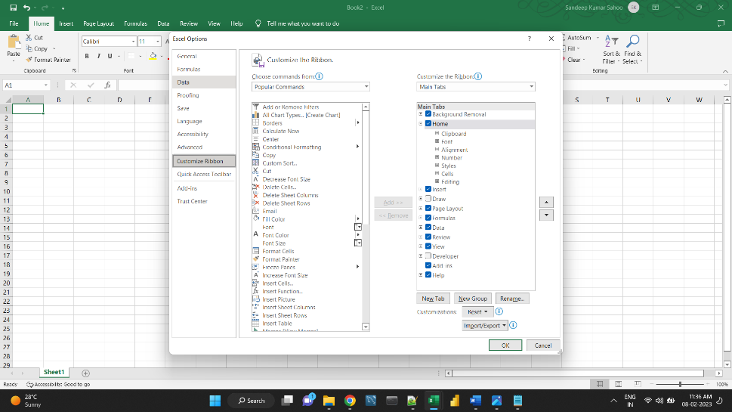

This adds a custom tab with a custom group because commands can only be added to custom groups.

Select the newly created tab, named New Tab (Custom), and click the Rename… button to give your tab an appropriate name. In the same manner, change the default name given by Excel to a custom group.

When done, click OK to save the changes

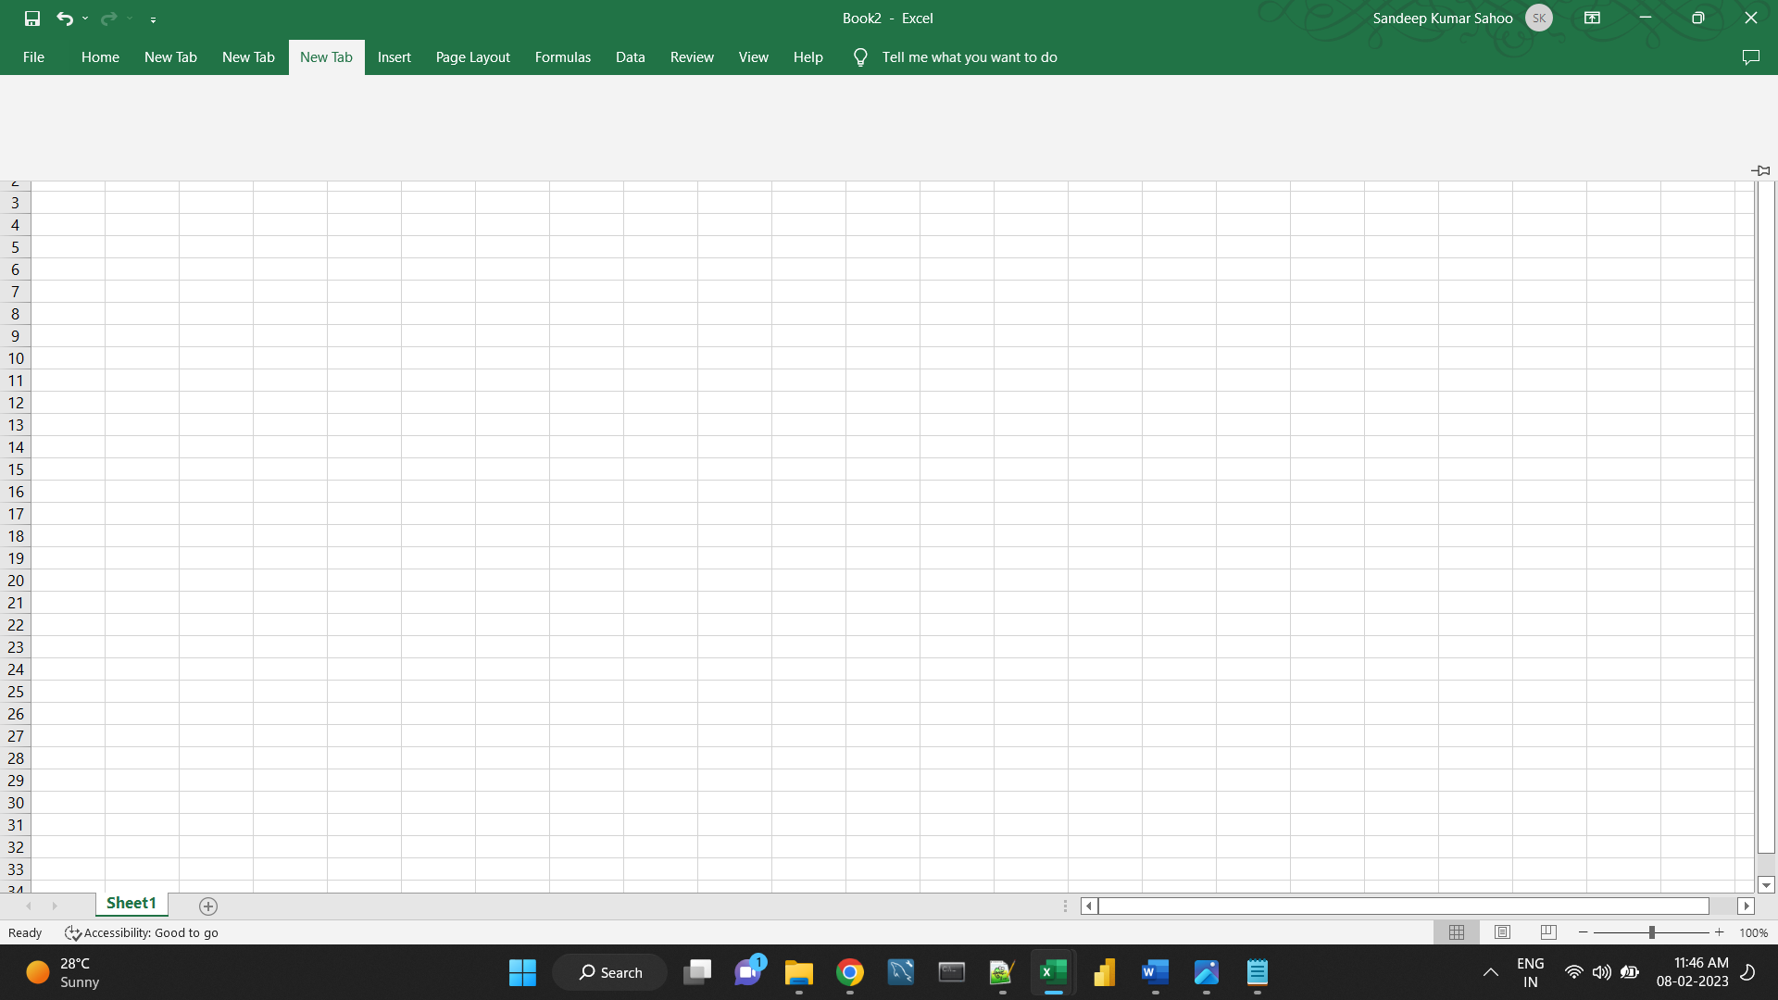

**New Tab**

**Step-2**

1. In the right part of the *Customize the Ribbon* window, select the tab to which you'd like to add a new group.
2. Click the **New Group**button. This adds a custom group, named *New Group (Custom)*, at the bottom of the list of groups, meaning the group displays on the
3. far-right end of the tab. To create a new group in a specific location, select the group after which the new group is to appear

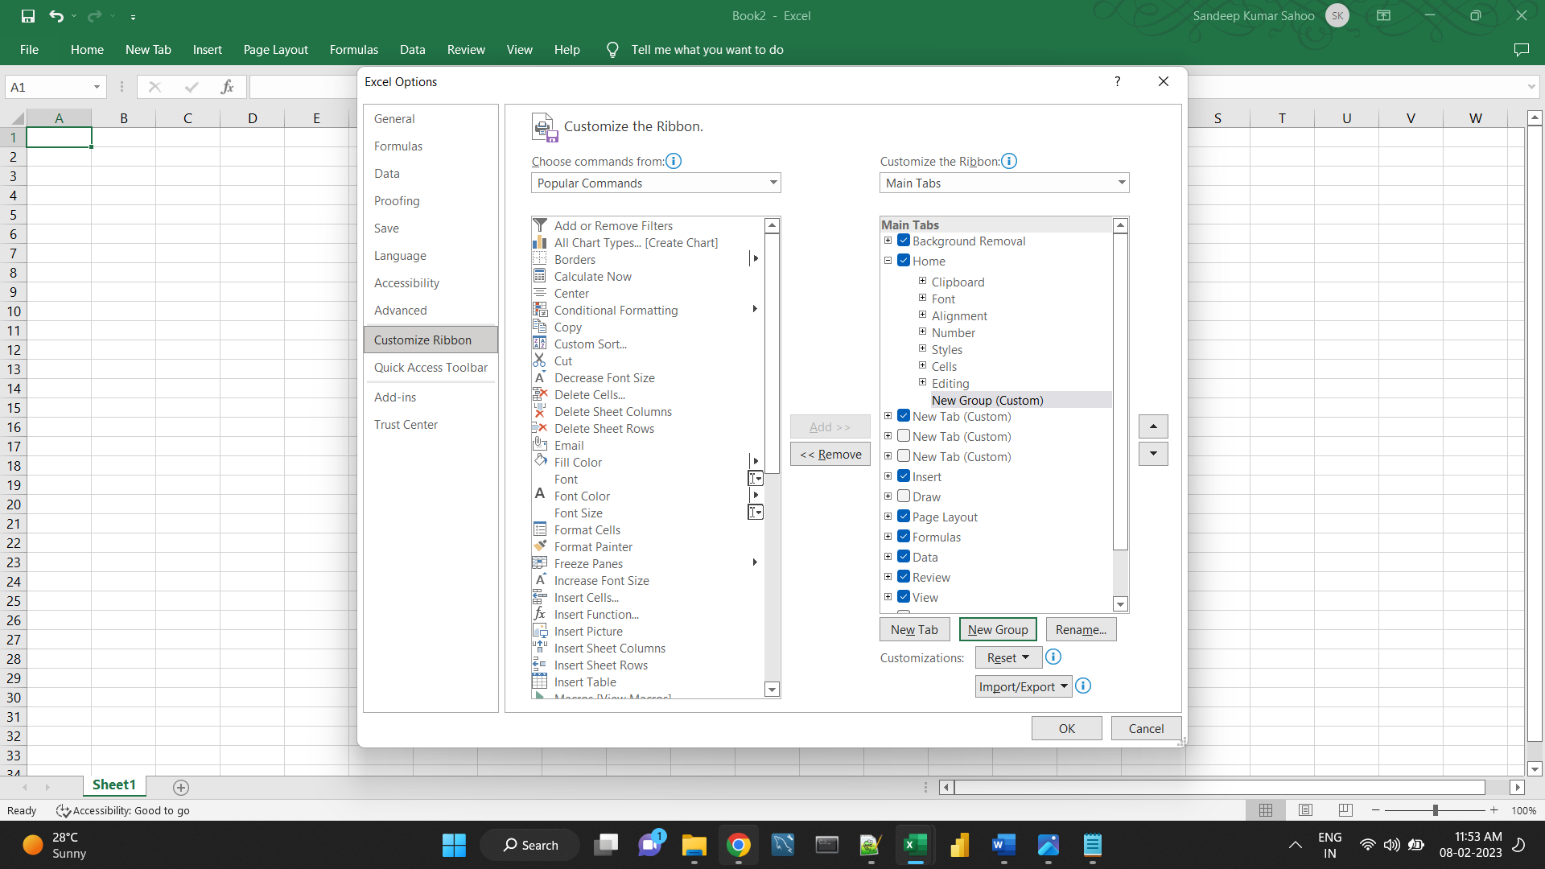

To rename your custom group, select it, click the Rename… button, type the desired name, and click OK.

Optionally, from the Symbol box, select the icon to represent your custom group. This icon will appear on the ribbon when the Excel window is too narrow to show the commands, so only the group names and icons are displayed

1. Click *OK* to save and view your changes.

**Step-3**

1. In the list under *Customize the Ribbon*, select the target custom group.
2. In the *Choose commands from* drop-down list on the left, select the list from which you want to add commands, for example, *Popular Commands* or *Commands Not in the Ribbon*.
3. In the list of commands on the left, click the command you want to add.
4. Click the **Add** button.
5. Click *OK* to save the changes

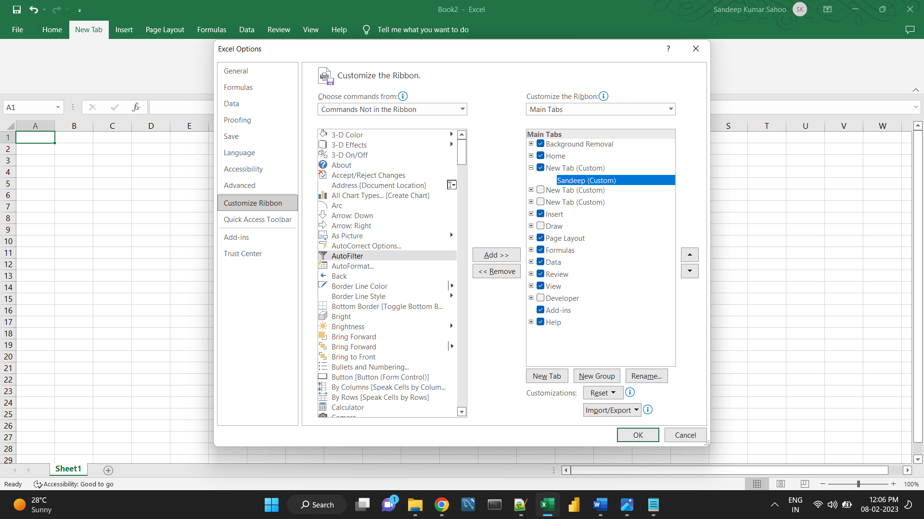

As the result, we now have a custom ribbon tab with two buttons:

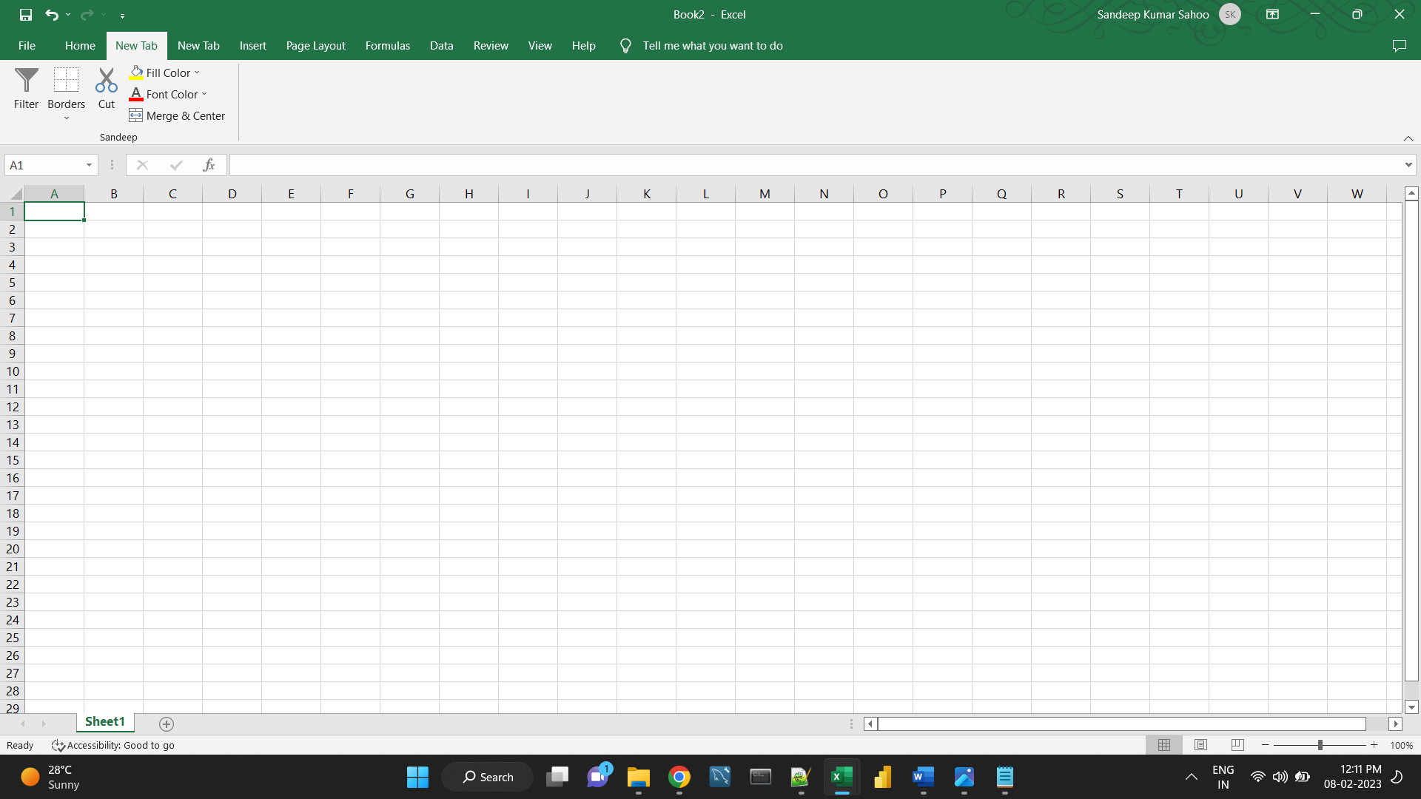

**4. Make a list of different shortcut keys that are only connected to**

**formatting with their functions.**

Ctrl + A: Select all contents of the page.

Ctrl + B: Bold highlighted selection.

Ctrl + C: Copy selected text.

Ctrl + X: Cut selected text.

Ctrl + P: Open the print window.

Ctrl + F: Open find box.

Ctrl + I: Italic highlighted selection.

Ctrl + K: Insert link (Shortcut Keys and their Functions).

Ctrl + U: Underline highlighted selection.

Ctrl + V: Paste.

Ctrl + Y: Redo the last action performed.

Ctrl + Z: Undo last action.

Ctrl + L: Aligns the line or selected text to the left of the screen.

Ctrl + E: Aligns the line or selected text to the center of the screen.

Ctrl + R: Aligns the line or selected text to the right of the screen.

Ctrl + M: Indent the paragraph.

Ctrl + Shift + F: Change the font.

Ctrl + Shift + >: Increase selected font +1pts up to 12pt and then increases font +2pts.

Ctrl + ]: Increase selected font +1pts.

Ctrl + Shift + <: Decrease selected font -1pts if 12pt or lower, if above 12 decreases font by +2pt.

Ctrl + [: Decrease selected font -1pts.

Ctrl + Shift + *: View or hide non printing characters.

Ctrl + L: Moves one word to the left.

Ctrl + R: Moves one word to the right.

Ctrl + : Moves to the beginning of the line or paragraph.

Ctrl + : Moves to the end of the paragraph.

Ctrl + Del: Deletes word to right of cursor.

Ctrl + Backspace: Deletes word to left of cursor.

Ctrl + End: Moves the cursor to the end of the document.

Ctrl + Home: Moves the cursor to the beginning of the document.

Ctrl + Spacebar: Reset highlighted text to the default font.

Ctrl + 1: Single-space lines.

Ctrl + 2: Double-space lines.

Ctrl + 5: 1.5-line spacing.

Ctrl + Alt + 1: Changes text to heading 1.

Ctrl + Alt + 2: Changes text to heading 2.

Ctrl + Alt + 3: Changes text to heading 3.

Alt + Shift + D: Insert the current date.

Alt + Shift + T: Insert the current time.

**6. What distinguishes Excel from other analytical tools?**

Excel is a useful tool for the businesses. Companies use the software to organize the data and maximize returns on investment.

**Benefits**

The excel spreadsheet displays financial information in an organized manner. The information could be related to the sales, management department, HR or the marketing. Most of the businesses are dependent on IT sector and therefore excel is a vital tool to run a business. Read on to learn about the topmost features of this software.

It builds the charts

It makes use of conditional formatting

It helps to organize the data

It will identify trends

It provides online access

Excel will use range of formulas to unlock the potential of data. You have to insert data in individual cells of columns and rows. In this way, data will be filtered and sorted and hence displayed in a presentable manner. Different types of charts like clustered columns, graphs and pie chart provide great visual presentation. It puts more emphasis to marketing material and business reports. Excel is a wonderful tool to represent data on X and Y axis.

**The brilliant interface for users**

It provides different colour shades, font types to format the spreadsheet and differentiate between rows and columns. It is good to present useful presenting information such as balance, tax profit etc. There is a quick analysis button to choose the appropriate colouring scheme.

You could combine the information from different files and documents to Excel. In this way, they will exist in a single location. Besides the regular information and raw data from spreadsheets, it is easy to import the images too. You just need to use the insert tab to add multiple objects to the spreadsheet.

**7.Create a table and add a custom header and footer to your table.**

